SN Corporate Rating Model – Methodology
1. Purpose
This tool implements a simple, transparent corporate credit scoring model that maps a 0–100 score to an alphabetical letter grade (AAA–CCC-). It is designed for educational and exploratory use, not for regulatory capital or production-grade ratings.
2. Credit rating
A credit rating is an assessment of an entity’s ability to pay its financial obligations – its creditworthiness. Ratings are assigned to corporations, financial institutions, insurers, municipalities, and sovereigns that issue debt securities such as bonds and notes. Ratings provide a relative ranking of credit risk: higher ratings imply a lower likelihood of default. A credit rating is not investment advice and should not be viewed as a recommendation to buy, sell, or hold securities.
3. Scope
The model consists of:
- A quantitative block based on financial ratios.
- A qualitative block based on 1–5 expert assessments.
These two blocks are combined into a single score, which is then mapped to a rating and an outlook (Positive/Stable/Negative).
Furthermore, the rating of the entity is capped at the sovereign long-term foreign-currency rating, if provided. The sovereign cap only binds when the model-implied (uncapped) rating is better than the sovereign; if the uncapped rating is at or below the sovereign, the sovereign does not affect the issuer’s rating or outlook. This model does not implement exceptions (e.g. structural insulation or ratings above the sovereign).
Reason: corporates share the same macro, legal, and transfer-and-convertibility risks as the sovereign, so their ability and willingness to service foreign-currency debt cannot be structurally stronger than that of the state that controls their operating environment.
(Implementation note: the rating engine is implemented as the class SN_CorporateRatingModel in python, which returns results in a structured dataclass SN_RatingComponents.)

4. Rating scale and score mapping
4.1 Score-to-rating grid (min–max bands)
The model uses a 0–100 internal score and maps it to ratings in fixed 5-point bands, stored as (min_score, max_score, rating). The current grid is:
- AAA: 95–100
- AA+: 90–94
- AA: 85–89
- AA−: 80–84
- A+: 75–79
- A: 70–74
- A−: 65–69
- BBB+: 60–64
- BBB: 55–59
- BBB−: 50–54
- BB+: 45–49
- BB: 40–44
- BB−: 35–39
- B+: 30–34
- B: 25–29
- B−: 20–24
- CCC+: 15–19
- CCC: 10–14
- CCC−: 0–9
The helper score_to_rating(score), function in python, scans this grid and returns the rating whose band satisfies min_score <= score <= max_score.
Default status is outside the scope of this model and no explicit “default” grade is included.

5. Quantitative block
5.1 Ratios covered
The quantitative block uses standard leverage, coverage, profitability, liquidity, and maturity ratios:
- Leverage / coverage
  - Debt / EBITDA
  - FFO / Debt
  - EBITDA / Interest
  - FFO / Interest
  - CFO / Interest
  - CFO / Debt
  - Debt / Capital

- Profitability / returns
  - EBIT margin
  - EBITDA margin (EBITDA / revenue)
  - ROE
  - ROA
  - ROIC
- Liquidity / maturity
  - Current ratio
  - Quick ratio
  - Cash / short-term debt
  - Cash / total debt
  - “Maturity wall” ratio (debt maturing in a near-term window / total debt)
You can supply any subset of these ratios in the financials dict; missing ratios are ignored.
5.2 Level-based scoring and negative values
For each quantitative ratio, the model applies a two-step process:
- Map the raw ratio value to a 1–5 strength level using a ratio-specific grid.
- Convert that level to a 0–100 score using a common mapping.
5.2.1 Level grids (1 = strongest, 5 = weakest)
Each ratio has its own level grid of the form:
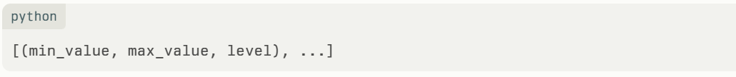
These grids are defined in the code, for example for FFO / Debt:
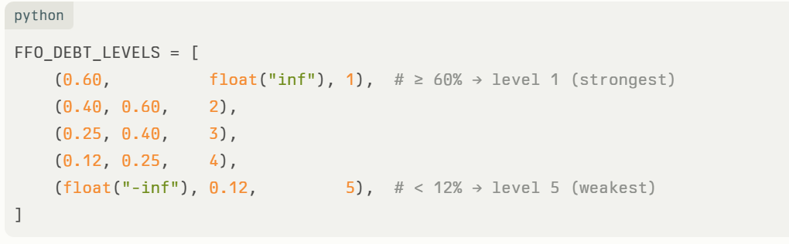Here, level 1 is strongest, level 5 is weakest.

5.2.2 Converting level to score and handling negatives
All ratios share a single mapping from levels 1–5 to scores 0–100:
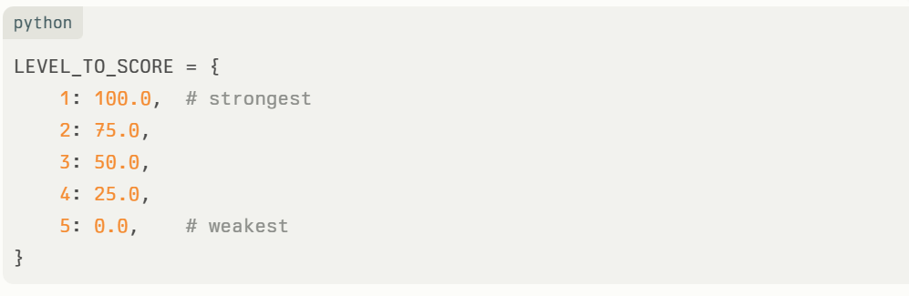The helper function
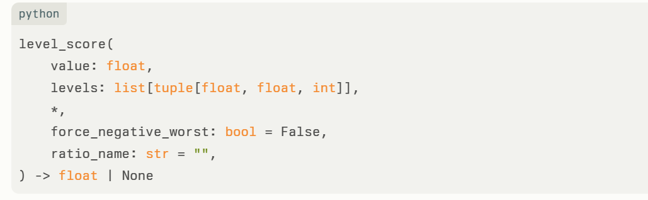works as follows:
- If value is None, it returns None (ratio is skipped).
- If force_negative_worst is True and value < 0, it forces level 5 and returns a score of 0 (worst), and logs this override.
- Otherwise, it finds the first (min_value, max_value, level) in levels such that min_value <= value < max_value, and returns LEVEL_TO_SCORE[level].
- If no interval matches (which should not happen with realistic grids), it returns None.
For the following ratios, force_negative_worst=True is used, because negative values are treated as very weak credit signals and mapped directly to the worst bucket:
- Debt / EBITDA
- FFO / Debt
- EBITDA / Interest
- FFO / Interest
- CFO / Interest
- CFO / Debt
- EBIT margin
- EBITDA margin
- ROE
- ROA
- ROIC
Liquidity ratios (current ratio, quick ratio, cash / debt, maturity wall) are scored without special negative handling, as they are expected to be non-negative for meaningful inputs.
5.3 Aggregation
compute_quantitative_score():
- Iterates over all ratios present in financials.
- For each defined ratio, calls level_score(...) with the appropriate level grid and force_negative_worst flag.
- Collects all non-None scores.
- If no ratios are provided or all are invalid, defaults the quantitative block score to 50.0 and logs a warning.
- Otherwise, returns the simple arithmetic mean of all ratio scores, rounded to one decimal.
All ratios present receive equal weight inside the quantitative block. This is a modelling simplification.

6. Qualitative block
6.1 Structure and inputs
The qualitative block has three buckets:
- business_risk
- management_governance
- country_structural
Each bucket contains several factors scored from 1 to 5 (int or float).
On this 1–5 scale, 1 represents a very strong factor assessment and 5 represents a very weak assessment; 3 is a neutral or average assessment.
You can add more numeric factors under these three buckets; all are included automatically.

For example:
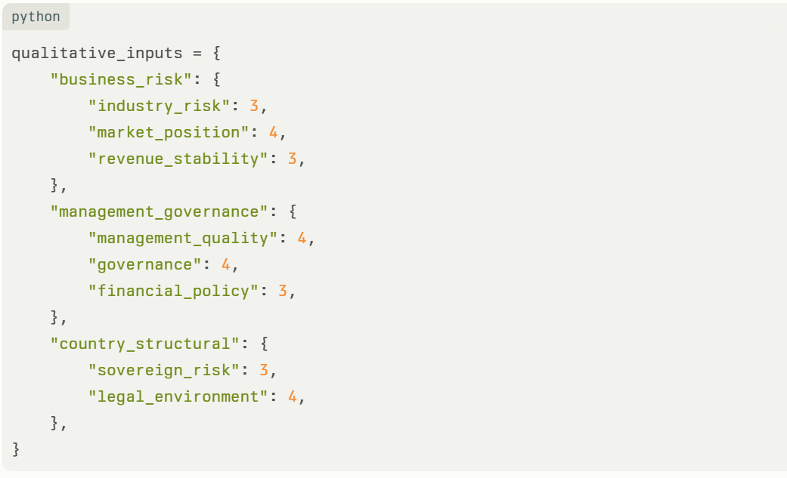
6.2 Validation and error handling
compute_qualitative_score() enforces:
- Numeric only: non-convertible values are skipped and logged.
- Hard range [1.0, 5.0]: values outside this interval are skipped and logged, rather than clamped.
- If no valid qualitative factors remain, the block defaults to 50.0 and logs a warning.
This prevents erroneous inputs or outliers from distorting the qualitative score.
6.3 Mapping 1–5 to 0–100
Each valid qualitative factor on the 1–5 scale is mapped using the same LEVEL_TO_SCORE mapping as the quantitative block:
- 1 → 100
- 2 → 75
- 3 → 50
- 4 → 25
- 5 → 0
In other words, lower numeric values (1–2) represent stronger qualitative assessments and translate into higher scores.
compute_qualitative_score():
- Converts each input to float and checks it lies in [1.0, 5.0].
- Rounds to the nearest integer level (1–5).
- Converts that level to a 0–100 score using LEVEL_TO_SCORE.
- Averages all mapped scores across all buckets and returns the mean (one decimal).
- If no valid factors remain, defaults to 50.0 and logs a warning.
All qualitative factors have equal weight.

7. Combining blocks and assigning a rating
7.1 Weights
Current configuration (no explicit modifier block):
- Quantitative weight (input): 65%
- Qualitative weight (input): 35%
Inside the model class, these weights are normalized so they always sum to 100% even if the user passes values that do not add up to 1.0. This ensures they are treated as proportions of the total score.
The combined score is:
$$\text{combined_score}=w_{\text{quant}}⋅\text{quantitative_score}+w_{\text{qual}}⋅\text{qualitative_score}$$
with $w_{\text{quant}}+w_{\text{qual}}=1$ after normalization.
7.2 Uncapped vs final rating
The main rate() python method:
- Computes quantitative_score.
- Computes qualitative_score.
- Computes combined_score.
- Maps combined_score to an uncapped_rating using score_to_rating().
- If a sovereign_rating is supplied, applies apply_sovereign_cap() to get final_rating, and tracks whether the cap is binding (final_rating != uncapped_rating).
- Derives the outlook (Section 8).
- Enforces that a final rating of AAA cannot have a Positive outlook (AAA can only be Stable or Negative).
- Returns all components, including a Boolean flag capped_by_sovereign.
If no sovereign_rating is supplied, final_rating = uncapped_rating.

8. Outlook methodology
8.1 Band-based rule on the uncapped rating
The primary outlook logic uses the uncapped rating band and the combined score’s position inside that band:
- The model finds the (min_score, max_score) band for the uncapped rating.
- It compares combined_score to the band edges:
  - If combined_score is exactly at the upper edge of the band → outlook = Positive.
  - If combined_score is exactly at the lower edge of the band → outlook = Negative.
  - Otherwise (strictly between lower and upper within that band) → outlook = Stable.
Example for AA+ (band 90–94):
- 94 → Positive
- 90 → Negative
- 91–93 → Stable
This is implemented in derive_outlook(combined_score, rating).
8.2 Interaction with the sovereign cap
In rate():
- If the sovereign cap is binding (final_rating worse than uncapped_rating):
  - If a sovereign_outlook is provided, the issuer outlook is set equal to the sovereign outlook (Positive/Stable/Negative).
  - If no sovereign_outlook is provided, the issuer outlook defaults to Stable.
- If the sovereign cap is not binding (no sovereign given, or uncapped_rating ≤ sovereign_rating):
  - The issuer outlook is derived purely from the uncapped rating band via derive_outlook() as described above.
Finally, if the resulting final_rating is AAA and the outlook is Positive, the model forces the outlook to Stable, since there is no higher rating for an upgrade.
8.3 Interpretation
- Positive: score is at the very top of its current band, mechanically close to the next higher rating (except AAA, where this is normalized to Stable).
- Negative: score is at the very bottom of its current band, signalling vulnerability to a downgrade.
- Stable: score is comfortably within the band.
This is a simple, mechanical rule-of-thumb and not a forward-looking forecast model.

9. Logging and transparency
The model uses Python’s logging to provide an audit trail:
- Each quantitative ratio: input value, handling of negative values, and assigned score.
- Each qualitative factor: raw input, mapped score, or reason for skipping.
- Quantitative and qualitative block averages.
- Combined score, uncapped rating, and whether the sovereign cap bound.
- Sovereign cap application details.
- Outlook band edges, score position, and any overrides (e.g. AAA outlook forced to Stable).
Example log extract for a single issuer, showing how ratios and qualitative factors are mapped to scores, and how the final rating and outlook are derived.
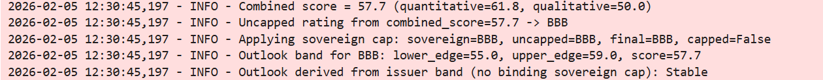
This helps users understand how a particular rating outcome was reached and debug input issues.

10. Key assumptions and limitations
10.1 Simplifying assumptions
- Equal weighting within blocks:
  - All quantitative ratios in the block have the same weight.
  - All qualitative factors have the same weight.
  - In practice, agencies often weight certain metrics or factors more heavily.
- Static grids:
  - Ratio grids are hard-coded and not calibrated to empirical default data.
  - They reflect generic credit logic (stronger ratios → higher score) but are not backed by Probability of Default calibration.
- Linear level → score mapping for qualitative factors:
  - Real-world methodologies often use non-linear scales or descriptive levels (e.g., “Strong / Satisfactory / Weak”) instead of a simple linear 1–5→score transformation.
- Simple sovereign cap:
  - No modelling of transfer risk, structural subordination across jurisdictions, or partial ring-fencing.
- Mechanical outlook rule:
  - Outlook is purely a function of band position, without forward-looking judgement or scenario analysis.
  - It ignores trends in metrics or expected future performance.
10.2 What this model is not
- It is not a Basel-compliant IRB model, does not estimate PD/LGD/EAD, and is not suitable for regulatory capital.
- It is not a recreation of any specific Credit Rating Agency’s proprietary methodology.
- It is not validated on historical default data or portfolio performance.
- The model addresses credit risk only; it does not address other risks such as liquidity risk, interest rate or market risk.
This is a transparent template to illustrate how a score-card-style corporate rating tool can be constructed.

11. Strengths and weaknesses
11.1 Strengths
- Transparency:
All grids, weights, and mappings are explicit in code and easy to modify.
- Explainability:
Each ratio and qualitative factor has a visible score; logs show how the final rating emerges from inputs.
- Robustness to bad inputs:
Non-numeric and out-of-range qualitative values are skipped rather than breaking the model. Missing ratios default to a neutral block score when none are available.
- Modularity:
Clear separation of quantitative, qualitative, mapping, and outlook logic, making it easy to extend (e.g., add sector-specific grids or GRE support modifiers).
11.2 Weaknesses / caveats
- No calibration: The score-to-rating mapping is heuristic, not calibrated to observed default frequencies or to external ratings.
- Equal weights: All ratios and qualitative factors are treated equally, which may under- or over-weight critical drivers in specific industries.
- Static, point-in-time view: Uses a snapshot of ratios; does not blend history and forecasts in a structured way. No automatic trend or volatility metrics.
- No explicit treatment of off-balance-sheet or GRE support yet in the final score:
While the code can be extended, the current implementation does not add explicit support notches, extraordinary support, or off-balance-sheet adjustments as separate modifiers.

12. Intended use and extension ideas
This tool is best used for:
- Educational purposes: understanding how a simple, rule-based rating engine can be built.
- What-if analysis: exploring how changes in leverage, coverage, or qualitative assessments move the rating.
- Prototyping: as a starting point for more sophisticated internal models.
Potential extensions:
- Sector-specific ratio grids and weights.
- Separate stand-alone credit profile vs. support (e.g., for GREs or strong parents).
- Incorporating multi-year data and trends.

